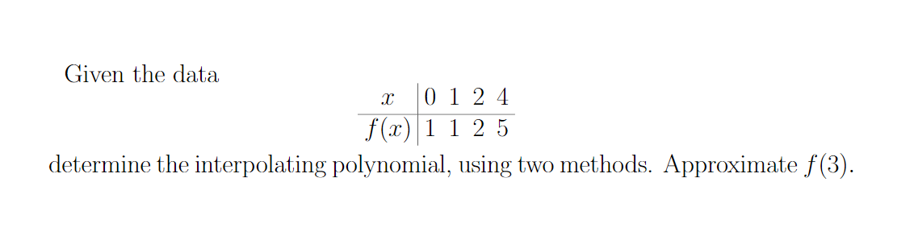

Given the data

2 0 1 2 4

f(x) 1 1 2 5 determine the interpolating polynomial, using two methods. Approximate f(3).